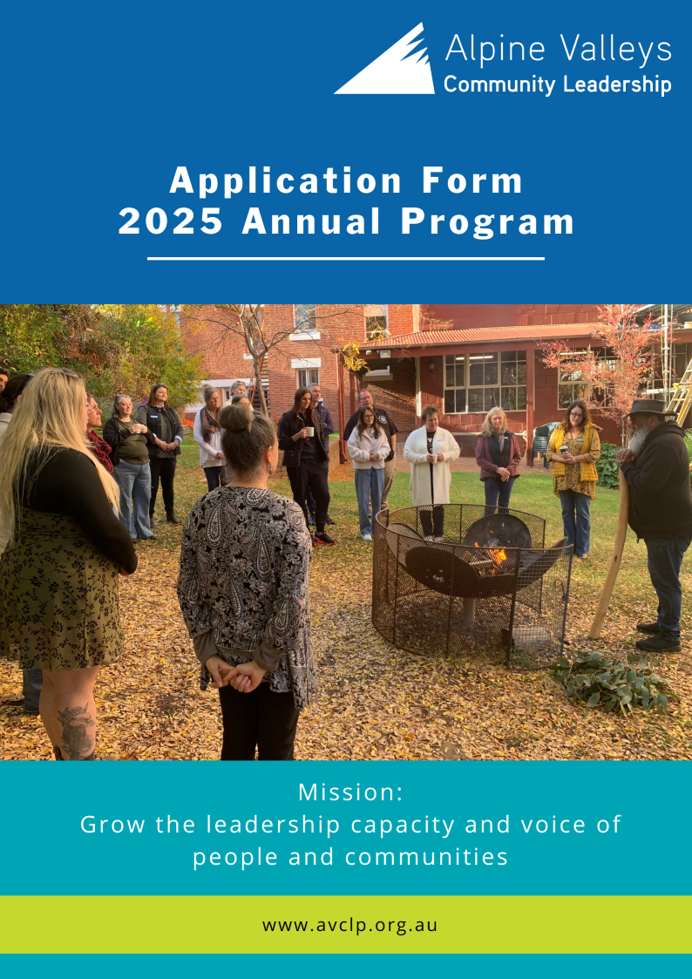

Confidential **Application**

The Alpine Valleys Community Leadership Annual Program (AVCLP) has enabled leadership development across the North-East and Border communities since 1998, with an Alumni base of over 500 graduates. Thank you for applying to participate in our 2025 Annual Program.

**Application Process**

* Applications open early August 2024.
* Applications close late September 2024.
* Please complete the web-form application (preferred); or submit hard copy completed application to [leaders@avclp.org.au](mailto:leaders@avclp.org.au)
* Applications will be reviewed by a panel and all applicants will be required to attend an interview.
* Interviews will take place via Zoom in October 2024.
* Following completion of all interviews, the selection panel will convene to determine suitability and funding allocations.
* All applicants will be informed of the outcome in late November 2024.
* The program will commence in February 2025. **Successful applicants will be required to attend the compulsory Program Launch** on Thursday 13th February, and **Opening Retreat**, scheduled for Friday 21st and Saturday 22nd February 2025.

**Instructions and Advice for Applicants**

1. The selection panel uses the criteria detailed in this application. Please read and answer these questions carefully.
2. Complete each section in full.
3. Type or print all answers clearly.
4. Limit answers to available space.
5. Applicants must have the full support of the organisation they represent. Individuals without a funding organisation who are seeking a scholarship may nominate themselves.
6. All nominations are subject to confidential evaluation.
7. Attendance at the Launch, Opening, Mid-Year, Closing Retreats and Graduation is mandatory. Participants must meet the minimum participation requirements to graduate from the Program.
8. For each Program intake, a diverse mix of multicultural, indigenous, ethnic, and religious, gender, location, private/public, and profit/non-profit sector participants are sought. The Program is committed to selecting candidates that represent communities from across the entire region.
9. Given the time commitments required to complete AVCLP, and to be fair to the individual, their employer, and their families, it is unlikely that the panel will select an applicant who is also enrolled in other tertiary studies.
10. Offers in the program will be made in late November. Program fees are to be paid in January, prior to commencement of the program, unless other arrangements are made.

**NOTE:** AVCLP is highly regarded, and places are sought after. Suitable applicants may not be chosen due to size restrictions, unavailability of a scholarship, and the need for diversity in group composition. Therefore, individuals not selected are strongly encouraged to reapply in subsequent years.  
  
**For questions regarding the application process, please contact the Program Manager, Irene Pritchard via** [**leaders@avclp.org.au**](mailto:leaders@avclp.org.au) **or Executive Officer, Madeline Hines via** [**eo@avclp.org.au**](mailto:eo@avclp.org.au)

# Alpine Valleys Community Leadership Program Application

**Contact Details**

|  |  |
| --- | --- |
| Full Name: | Preferred Name: |
| Pronouns: | Gender: |
| Year of birth (eg. 1978): | Spoken Languages: |
| Home Address: | Email: |
| City: Postcode: | Ph No: |
| Local Govt Area (reside): | Local Govt Area (work): |

**Inclusion & Accessibility**

*AVCL endorses equal opportunity in participating in the Annual Program; we provide the same benefits and opportunities to all applicants, without discriminating due to protected characteristics such as age, gender, sexual orientation, ethnicity, nationality, religion, disability, and medical history. AVCL aims to promote participation in the program on an equitable basis, and will accommodate any participants as necessary to ensure their inclusion in the program. The following questions are included to help support inclusive participation within the program, and may be used in deidentified statistical reporting:*

|  |
| --- |
| Do you identify as Aboriginal or Torres Strait Islander? Yes No |
| Do you identify as Culturally and Linguistically Diverse (CALD)? Yes No |
| Do you consider yourself to have a disability or health condition, including physical, intellectual or mental health related? Yes No |

*AVCL Fund Ltd is an ACNC registered charity with Deductible Gift Recipient status, through which we raise funds to support scholarship opportunities for participants who are experiencing disadvantage within the community, or who may be suffering from discrimination and social isolation, including those from indigenous, ethnic or LGBTQI backgrounds.*

*The below questions are asked to ensure scholarship funds raised by AVCL Fund Ltd are allocated to qualifying participants in line with our established purpose. Note that through our diverse funding streams, other scholarships are available for participants who are not experiencing disadvantage or suffering from discrimination and social isolation.*

*Disadvantage can include: People living with a disability or long-term physical or mental health condition; Culturally and linguistically diverse (CALD) people; identifies as Aboriginal or Torres Strait Islander; is a member of a minority group or community including LGBTIQA; is experiencing socio-economic barriers that include financial disadvantage, including concession or health-care card holders; are long-term unemployed; or experiencing disadvantage due to specifically identified scenarios, including the impact of a natural disaster, such as bushfires or floods.*

|  |
| --- |
| Are you experiencing disadvantage* (refer above description, noting this list isn’t exhaustive and further qualifiers of disadvantage may be accepted through a further discussion): Yes /  No / Not Sure |
| Are you suffering from discrimination and/or social isolation, including those from indigenous, ethnic or LGBTQI backgrounds: Yes /  No / Not Sure |

**Employment Information**

|  |  |
| --- | --- |
| Employer: | |
| Manager Name: |  |
| Work Address: |  |
| City: Postcode: | Work Ph: |
| Job Title/Role: | |
| Years of Employment: | |

**Employment Experience**

List relevant employers within last ten years, starting with your most recent employment.

|  |  |  |
| --- | --- | --- |
| **Employer** | **Job Title/Role** | **Years of Employment** |
|  |  |  |
|  |  |  |
|  |  |  |

**Education**

Provide details of any relevant qualifications, professional development or leadership courses including units you have recently completed via employment, study and/or volunteer work.

|  |
| --- |
|  |

Will you be enrolled in a formal course of study over the next 12 months?  Yes  No

*If yes, please provide details below:*

|  |
| --- |
|  |

**Your Leadership Journey**

Why are you applying for this program? What are your goals / intended outcomes?

|  |
| --- |
|  |

What do you consider to be your most significant community contribution to date? (This can be through volunteering, or contribution within the region / community as achieved through your employment.)

|  |
| --- |
|  |

What skills and knowledge would you personally like to develop through the program, to make a greater contribution to your community?

|  |
| --- |
|  |

**Community Activities and Organisations**

Please list in order of importance to you, up to five community, civic, professional, religious, social, sports or other organisations of which you are, or have been a member. Please include the name of group/organisation, what role/position you held and dates (year is fine).

|  |
| --- |
|  |

How do you envision your community, or the broader region, will benefit from your participation in the program?

|  |
| --- |
|  |

**Vision for the Region**

From your perspective, what do you feel are the three most significant challenges facing the Ovens Murray region today?

|  |
| --- |
|  |

What are three exciting opportunities available to the Ovens Murray region:

|  |
| --- |
|  |

What is your vision for the Ovens Murray region for the year 2030? What part would you have liked to have played in the achievement of that vision?

|  |
| --- |
|  |

**References**

|  |  |
| --- | --- |
| **Referee 1** | **Referee 2** |
| Name: | Name: |
| Title: | Title: |
| Relationship: | Relationship: |
| Organisation: | Organisation: |
| Phone: | Phone: |
| Email: | Email: |
| Have you applied previously? If so, what year? | |

## Funding Information

Fees for the 2025 Annual Program are made up of:

* Participant contribution of $1,000 plus GST ($1,100)
* Funding from your sponsoring organisation (workplace, member organisation/group) or through a scholarship, for the amount of:
  + $6,000 (*limited placements at this rate), or
  + $9,000

If you are being supported by your workplace, please speak with your manager or relevant departmental head to clarify if they are intending to support your placement at the rate of $6,000 or $9,000. Further information as to the details of the different funding tiers can be found on our website: <https://bit.ly/Prospectus2025>

Please indicate your sponsorship arrangements:

I understand that I will make a personal contribution of $1,000 plus GST ($1,100)

**And** (select the option relevant to your situation):

I have a workplace / organisation who will pay the program fee of (please tick to indicate):

$6,000 plus GST ($6,600)

$9,000 plus GST ($9,900)

I will sponsor myself for the program fee of (please ticket to indicate):

$6,000 plus GST ($6,600)

$9,000 plus GST ($9,900)

I do not have a workplace / sponsor and am interested in my suitability for a scholarship.

I have a sponsor who has agreed to partially fund me. This amount is ________

**Please note:** Our payment terms are 30 days from invoicing, and must be made before commencement of the program, unless other arrangements with the Program Manager are made. Refunds will not be available within 7 days of commencement of Opening Retreat.

## Sponsor Information

If you are being supported by your workplace or other organisation, please complete the following section. If you are seeking a scholarship, please skip this section. By completing this section, you confirm you are authorised to do so on behalf of your organisation and have their pre-agreement for the funding commitment.

|  |  |
| --- | --- |
| Sponsor Organisation: | |
| Contact Name: | Ph: |
| Work Address: | Email: |
| City: Postcode: |  |
| Sponsorship Amount: | |
| Conditions of Sponsorship (if any): | |

**Applicant Commitment**

***Acceptance into the Alpine Valleys Community Leadership Program is sought after, and competitive. We are only able to accept applicants who have considered the time commitment necessary for the successful completion of the Program and are willing to commit this time.***

To graduate from the Alpine Valleys Community Leadership Program, a minimum of 80% of the Program days must be attended.

This involves attendance at 15 days spread across the region, including:

* + Launch event
  + Two overnight retreats, that are scheduled for Fridays and Saturdays
  + A multi-day Study Tour in Melbourne, with accommodation available from the Sunday night, with the tour itself being overnight on Monday and concluding on Tuesday.
  + 12 single days, generally on a Friday at locations around the region.
  + 3 online sessions held in the evening via Zoom.
  + Attendance at Graduation / end of year celebration event

What percentage of Program days do you believe you will be able to attend? **(please tick)**

|  |  |  |
| --- | --- | --- |
| 100% | 90 – 100% | 80 – 90% |

## Mobilisation Activity:

As part of the 2025 program, participants will be mobilised through a team-based activity. This activity will require a small amount of time outside of annual program days, and could include team meetings, and undertaking your activity.

We suggest this component of the program may require 30-60 minutes per fortnight outside of program days.

***Please tick to confirm that you understand and agree to the time commitment for this***

**Applicant Commitment**

I understand the goals and time commitment of the Program.

If selected I will organise my work and personal commitments to devote the required time to the Program.

I understand that I am committing myself to increased community involvement in the community upon graduation.

|  |  |
| --- | --- |
| Signed: | Dated: |