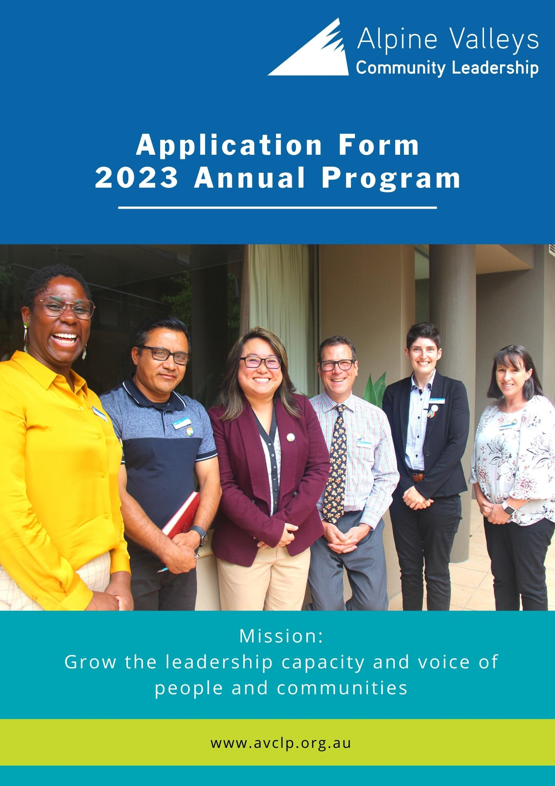

Confidential Application
The Alpine Valleys Community Leadership Program has been providing leadership development opportunities for North East and Border communities since 1998, with an Alumni base of over 450 graduates of the Annual Program. Thank you for applying to participate in our 2023 Program.
Application Process
- Applications close at 5pm, Sunday 11 September 2022
- Please email your completed application to leaders@avclp.org.au
- Applications will be reviewed by a panel and applicants will be required to attend an interview
- Interviews will take place in October
- All applicants will be notified of the outcome in late November
- Successful applicants will be required to attend the compulsory Program Launch in early February, and Opening Retreat, scheduled for Friday 10 and Saturday 11 February 2023.

Instructions and Advice for Applicants

- The selection panel uses the criteria detailed in this application. Please read and answer these questions carefully.
- Complete each section in full.
- Type or print all answers clearly.
- Limit answers to available space.
- One letter of recommendation will be accepted. No other attachments will be considered.
- Where applicable, applications must be signed by both the Applicant and their Sponsor.
- Applicants must have full support of the organisation they represent. Individuals may nominate themselves.
- All nominations are subject to confidential evaluation.
- Attendance at the Opening, Mid-Year, Closing Retreats and Graduation is mandatory. Participants must meet the minimum participation requirements to graduate from the Program.
- For each Program intake, a diverse mix of multicultural, indigenous, ethnic and religious, gender, location, private/public, and profit/non-profit sector participants are sought. The Program is committed to selecting candidates that represent communities from across the entire region.
- Given the time commitments required to complete AVCLP, and to be fair to the individual, their employer and their families, it is unlikely that the panel will select an applicant who is also enrolled in other tertiary studies.
- Offers in the program will be made in late November. Program fees are to be paid in January, prior to commencement of the program, unless other arrangements are made at interview.
NOTE: AVCLP is a highly regarded program and places are highly sought after. Some suitable candidates may not be chosen for this year’s Alpine Valleys Community Leadership Program because of the size restrictions of each year’s group and the need for diversity in group composition. Therefore, individuals not selected are strongly encouraged to reapply in subsequent years.
For questions regarding the application process, please contact the Program Manager, Suz Christison, on 0437 827 548, or via email leaders@avclp.org.au

Alpine Valleys Community Leadership Program - Application
Personal Information
Name: | Preferred Name:
DOB:
Pronouns: | Gender:
Home Address: | Home Ph:
City: Postcode: | Mobile:
Mailing Address: | Email:
City: Postcode: | Local Govt Area (reside):
Spoken Languages:
Do you identify as Aboriginal or Torres Strait Islander?
Do you identify as Culturally and Linguistically Diverse (CALD)?
Do you consider yourself to have a disability or health condition, including physical, intellectual or mental health related?
AVCL endorses equal opportunity in participating in the Annual Program; we provide the same benefits and opportunities to all applicants, without discriminating due to protected characteristics such as age, gender, sexual orientation, ethnicity, nationality, religion, disability, and medical history. AVCL aims to promote participation in the program on an equitable basis, and will accommodate any participants as necessary to ensure their inclusion in the program. We encourage applications from first nations peoples, those who are CALD, living with a disability, or of any other minority group.
Your Community Leadership
Why are you applying for this program? What are your goals / intended outcomes?

What do you consider to be your most significant community contribution to date (or future hopes)?

What skills and knowledge would you personally like to develop to make a greater contribution to your community?

Community Activities and Organisations
Please list in order of importance to you, up to five community, civic, professional, religious, social, sports or other organisations of which you are, or have been a member:
Organisation | Dates of Membership | Position(s) held | Hours involved p/week

What community organisation, roles or areas of interest would you be looking to in your future?

Employment Information
Employer:
Manager Name: | (N/A if not applicable)
Work Address: | Work Ph:
City: Postcode: | Email:
Job Title/Role:
Years of Employment:
Local Govt Area (work):

Employment Experience
List relevant employers within last ten years, starting with your most recent employment.
Employer | Job Title/Role | Years of Employment

Education
Please list secondary and tertiary education experience, beginning with most recent qualifications.
Institution | Location | Yrs Attended | Qualification(s) | Major Studies

Provide details of any relevant professional development or leadership courses including units you have recently completed via employment, study and/or volunteer work.

Will you be enrolled in a formal course of study over the next 12 months? □ Yes □ No
If yes, please provide details below
Community Vision
From your perspective, what do you feel are the three most significant challenges facing the Ovens Murray region today?

Name three exciting opportunities available to the Ovens Murray region:

What is your vision for the Ovens Murray region for the year 2030? What part would you have liked to have played in the achievement of that vision?

References
Referee 1 | Referee 2
Name: | Name:
Title: | Title:
Relationship: | Relationship:
Organisation: | Organisation:
Phone: | Phone:
Email: | Email:
Have you applied previously? If so, what year?

Sponsor Information
The fee for the 2023 Annual Program is $6,250 plus GST = $6,875. This consists of:

- A participant contribution of $800 plus GST = $880
- A workplace or sponsorship fee of $5,450 plus GST = $5,995

A limited number of scholarships may be available annually for candidates that do not have access to a sponsoring organisation. Please contact the Program Manager prior to or at the time of application to discuss your needs.
Please note: Our payment terms are 30 days from invoicing, and must be made before commencement of the program, unless other arrangements with the Program Manager are made. Course refunds will not be available within 7 days of commencement of Opening Retreat.
Please indicate your sponsorship arrangements:
- I have a sponsor who will pay the workplace / sponsorship program fee of $5,450 plus GST ($5,995)
- I understand that I will make a personal contribution of $800 plus GST ($880)
- I do not have a workplace / sponsor, and am interested in my suitability for a scholarship
- I will sponsor myself for the entire fee of $6,250 plus GST ($6,875)
- I have a sponsor who has agreed to partially fund me. This amount is ________
- I need to discuss my financial ability to participate (In this case please contact AVCLP asap)

Sponsor Organisation:
Contact Name: | Ph:
Work Address: | Email:
City: Postcode:
Sponsorship Amount:
Conditions of Sponsorship (if any):
ABN:

I, (contact name) agree on behalf of (sponsor organisation)
to sponsor (name) for the amount of $
Signed: | Dated:

Employer Commitment
I, the employer, have given my full support to my employee’s participation in the Alpine Valleys Community Leadership Program.
I am fully aware of the time commitment and organisational financial commitment as set out in the sponsor information table.
Name: | Title:
Organisation:
Signature: | Date:
Applicant Commitment
Acceptance into the Alpine Valleys Community Leadership Program is sought after, and competitive. We are only able to accept applicants who have considered the time commitment necessary for the successful completion of the Program and are willing to commit this time.
To graduate from the Alpine Valleys Community Leadership Program, the following is required:
A minimum of 80% of the Program days must be attended. This involves:
- Attendance at 20 Program days spread across the region, including:
  - Launch event, an evening in early February
  - three overnight retreats, that are scheduled for Fridays and Saturdays
  - an overnight Study Tour in Melbourne on a Monday and Tuesday
  - 12 single days, generally on a Friday at locations around the region
- Attendance at Graduation ceremony (week night)
What percentage of Program days do you believe you will be able to attend? (please tick)
□ 100% | □ 90 – 100% | □ 80 – 90%

Community Projects Participation:
Delivering a community project in a team is a requirement of AVCLP. This is a significant time commitment outside the program days and retreats.
A minimum 80% attendance at project team meetings, carrying out your appointed project team role, delivery of the project, and presentation of the project at Graduation is required. Where a project is not able to be delivered, the team will instead be asked to develop a paper or presentation around their experience and present this at Graduation.
We suggest that your community project may require 1-2 hours of time per week, dependent upon the nature of your project. Program Days have been scheduled every 3 weeks in 2023, to ensure participants have sufficient time between program days to work on their community projects.
□ Please tick to confirm that you understand and agree to the time commitment for community projects
Applicant Commitment
- I understand the goals and time commitment of the Program.
- If selected I will organise my work and personal commitments to devote the required time to the Program.
- I understand that I am committing myself to increased community involvement in the community upon graduation.

Signed: | Dated:

Submitting your application
Before submitting your application, please check that you have:
- Filled in all information sections
- Completed the Sponsors Information
- Completed the CEO or senior manager Employer’s Commitment (if applicable)

